Responsive Gamer Tag
Bio Link Page
Implementation, responsive testing, and screenshot evidence

1. Objective
To create a visually appealing, responsive gamer tag bio link page that presents a user's avatar, gaming alias, short biography, and direct links to Twitch, Discord, and Steam. The interface should remain readable and usable across mobile, tablet, and desktop viewports.

2. Design and Implementation
The page uses a dark gaming-inspired theme with purple accents, a centered profile card, a circular avatar, a prominent username (“ShadowX”), a short gaming tagline, and three large social buttons. Rounded corners, subtle borders, and a soft glow give the interface a polished appearance while keeping the content easy to scan.
- HTML5: Structures the profile card, avatar, alias, biography, and social navigation links.
- CSS Flexbox: Centers the card within the viewport and stacks the social buttons vertically.
- Responsive sizing: Uses width: 100% with a maximum card width so the layout can shrink on narrow screens.
- Media queries: Adjusts spacing and avatar/name sizing for small screens and larger viewports.
- Interaction and accessibility: Includes hover feedback, visible keyboard focus, descriptive image alt text, and navigation labeling.

3. Screenshot Evidence
The screenshot below records the implemented page running locally in Chrome with Chrome DevTools open. The visible viewport is narrow, showing the profile card in a single-column mobile-style layout.
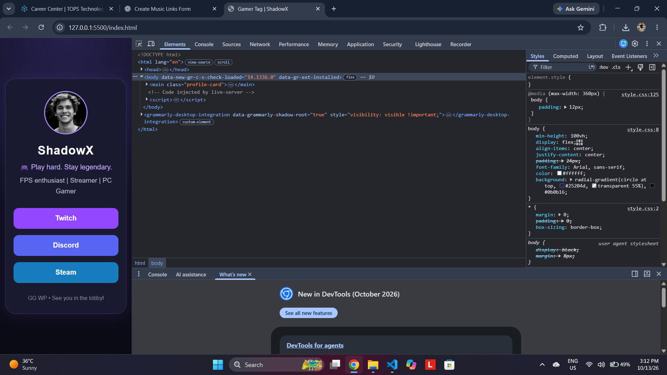
Figure 1. Gamer Tag page running locally in Chrome; narrow viewport and DevTools visible.

4. Responsive Testing Notes
Viewport | Expected/observed layout | Validation
Mobile (375 px) | Compact centered card; smaller avatar; vertically stacked buttons. | Screenshot evidence shows a narrow, single-column layout.
Tablet (768 px) | Centered card with increased padding and larger avatar. | Capture a tablet-width screenshot to document this viewport.
Desktop (1440 px) | Card remains centered and constrained to a readable maximum width. | Capture a desktop-width screenshot to complete the three-size test.
Note: The provided evidence shows one narrow viewport. Tablet and desktop behavior is described from the responsive CSS design and should be verified with additional screenshots before claiming that all three viewport tests are complete.

5. Outcome
The submitted implementation presents the essential gamer profile elements in a consistent visual hierarchy. Flexbox, flexible widths, and media queries support adaptation to different screen sizes. The page is ready for final cross-viewport verification and replacement of example profile URLs with the user's actual Twitch, Discord, and Steam links.

